For Academic Year 2020-21
Scholarship & Stipend

Post Matric Scholarship SC
Less than or Equal to Rs. 2,50,000 Haryana
>= 75%
Aadhar Card, Haryana Domicile, Income Certiﬁcate, Caste Certiﬁcate, 10th Certiﬁcate, 12th Certiﬁcate, Fee Receipt,
Parivar Pehchaan Patra, Last Exam Passed Certiﬁcate (Except for 1st Year Students), BPL Certiﬁcate (if applicable), Father's Death Certifcate (if applicable)

Post Matric Scholarship BC
Less than or Equal to Rs. 2,50,000 Haryana
>= 75%
Aadhar Card, Haryana Domicile, Income Certiﬁcate, Caste Certiﬁcate, 10th Certiﬁcate, 12th Certiﬁcate, Fee Receipt,
Parivar Pehchaan Patra, Last Exam Passed Certiﬁcate (Except for 1st Year Students), BPL Certiﬁcate (if applicable), Father's Death Certifcate (if applicable)

Note:
- All the basic Data will be fetched from Parivar Pehchaan Patra Data, Students are advised to update their complete data in Parivar Pehchaan Patra before Registration.

- If Students does not have Parivar Pehchaan Patra, they have to create the Parivar Pehchaan Patra ﬁrst.

How to Apply

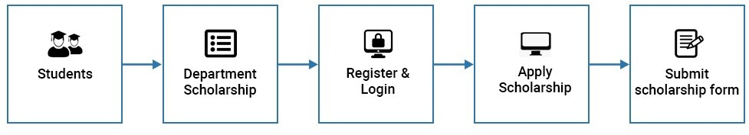
To Register and Apply the Scholarship, Eligible students need to follow the below given steps:

STEP 1 Click Registration link at the portal, if you are new user. Existing user can click on the login button.

STEP 2 Enter the Parivar Pehchaan Patra (Family Id), a List of members will be displayed, Select your Name and Click on "Generate OTP" button.

STEP 4 Enter the OTP received on your registered Mobile No. and Click on "Verify OTP" button.

STEP 5 AGer OTP Veriﬁcation, all the details get auto ﬁlled in the Registration Form, cross check your information.

STEP 6 Select Your Department and College, and create your Password and Click on "Register" Button.

STEP 7 Click login link at the portal and enter User ID and password to apply the scholarship.

STEP 8 Provide all necessary details like Course, Roll No., Eligibility etc.

STEP 9 Click on the “Apply” button to save your application.

Key Documents Required

- Aadhaar Card Copy
- Applicant’s Photograph
- Applicant's Signature
- Income Certiﬁcate
- Haryana Domicile Certiﬁcate
- Caste certiﬁcate
- 10th Class Certiﬁcate
- 12th Class Certiﬁcate
- Parivar Pehchaan Patra
- Fee Receipt
- Last Exam Passed Certiﬁcate (Except for 1st Year Students),
- BPL Certiﬁcate (if applicable)

Father's Death Certiﬁcate (if applicable)

